
A14
Sreenidhi Institute of Science & Technology
(An Autonomous Institution)
Code No: 4X104
M. TECH. I – Year I – Semester Examinations, March/April 2015, (Regular)
COMPUTER METHODS IN POWER SYSTEMS (EPE)

Time: 3 Hours Max. Marks: 60

Note: No additional answer sheets will be provided.

Part - A Max.Marks:10

Answer all QUESTIONS.
1. What is Incidence matrix?
2. What is the equation for Y_{BUS} using singular Transformation method?
3. What is the Mathematical expression for Z_{b} in ohms?
4. What is the value of operator ‘a’ in short Circuit Analysis?
5. What is the Mathematical expression for power flow equation in terms of active power?
6. What is the Assumption considered in fast decoupled power flow method?
7. What is the purpose of Ruge-Kutta method for power system stability studies?
8. Define Transient stability of power system?
9. Draw the graph for swing curve?
10. What is the function of Automatic Load frequency control?

Part – B Max. Marks: 50
ANSWER ANY FIVE QUESTIONS. EACH QUESTION CARRIES 10 MARKS.
1. a) Deduce the relation Y_{BUS} = A^{T}[Y]A.
b) For the following power system Network, obtain Y_{BUS} by singular Transformation if the reactance of each line is 0.02 PU and that of the general or is j0.04 PU. Consider each line has half-line charging admittance of j0.04 PU.
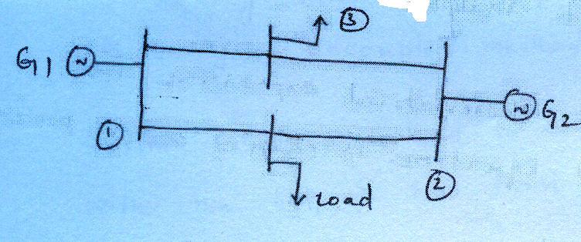
2. For the following power system network, obtain the bus impedance by using building algorithm by considering bus 1 as reference.
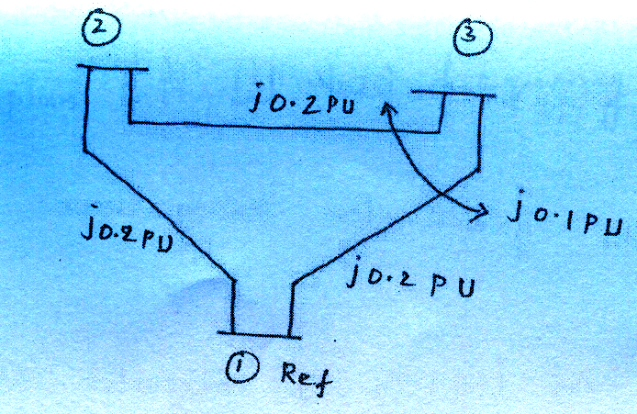
3. A synchronous generator rated 3 ϕ 11kv, 100 MVA has X₁=X₂=j0.1PU and X₀= j0.03PU. Determine fault current and line-to-line voltages during
i) SLG fault occurring on generator terminals. ii) If the generator neutral is solidly grounded.
4. Develop from basics, the equations for determining the elements of H and L matrices in the fast decoupled method.
5. Explain Euler’s method to solve swing equation with the help of two first order differential equations.
6. Explain various methods to improve Transient stability of power system.
7. Explain the significance of proportional plus integral load frequency control.
-- 00 -- 00 --

